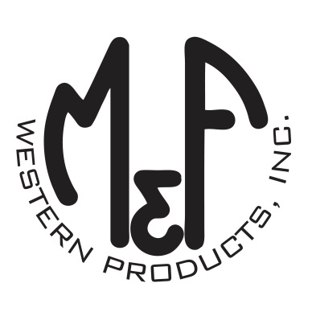

PRODUCT DESCRIPTION

**#N2301206**

**Details**

* “Austin”
* Nocona Made in USA Belt Collection
* Grey
* Mens Sizes: 32 to 46
* 1-1/2” Wide Hand Selected Top Grain Leather Strap
* Solid Strap
* Distressed Look
* Contrasting Stitching
* Plain Roller Buckle
* Handcrafted with Pride in the USA

**Description**  
  
*Quality and durability in a belt that is sure to get you noticed! Show off your American pride with Nocona Belt Made in the USA Collection by M&F Western Products. The beautifully handcrafted Austin mens belt is constructed of a hand selected, single piece of top grain leather with contrasting stitched edges. The silver roller buckle and leather keeper adds a touch of class. This classic belt is designed with the durability to withstand every day wear and is a perfect way to top off your attire for a night on the town.*

*As a general rule, if you wear size 34 jeans, your belt size is 36 (2” bigger).*