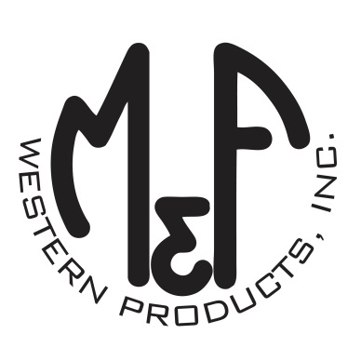

PRODUCT DESCRIPTION

**#B03660**

**Details**

* Boot Doctor Leathercare
* 3 oz. Mink Oil in Plastic Tub
* Conditions and Waterproofs
* For All Colors of Smooth Leather
* Rich Blend of Mink Oil
* May Darken Certain Leathers - Follow Instructions
* DO NOT USE ON NUBUCK, SUEDE OR EXOTIC
* Made in the USA
* Sold in Units of 6

**Description** *Premium quality leather care from Boot Doctor, by M&F Western Products. Boot Doctor Mink Oil is specially formulated to soften, condition and waterproof smooth leather. Keeps leather soft and pliable and prevents drying, cracking and salt stains. Recommended for smooth leather dress and work boots.*   
  
**Application Instructions:** Before use, see product description for more details on how to apply. It is recommended to do a small test area at a time for best results. May darken certain leathers.