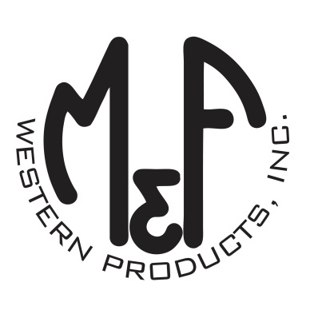

PRODUCT DESCRIPTION

**#A73216**

**Details**

* Ariat 10X
* Ivory
* Sizes: 6-3/4” to 7-5/8”
* Fancy Hatband
* Ariat Hat Pin
* Leather Sweatband
* Vented
* Crown: 4-1/4”
* Brim: 4-1/4”

**Description**  
  
*A cowboy has to have a great hat to be complete. You will love this Ariat 10X hat by M & F Western Products. It is complete with a fancy hatband and an Ariat hat pin. The unbeatable quality and durability of this hat are perfect for when you want to get dressed up, or just hanging out at the barn. Treat yourself today to this nice hat.*