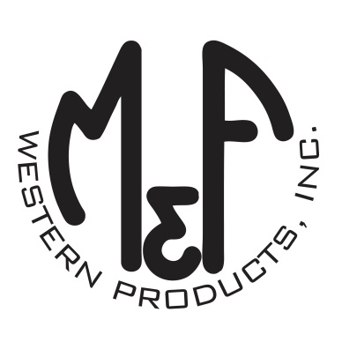

PRODUCT DESCRIPTION

**#A300006106**

**Details**

* Ariat Mens Cap
* Grey
* One Size: Adjustable Snap Closure
* 6 Panels
* Fit: Richardson 112
* Ariat Signature Logo on Texas Patch
* White Contrast Stitching
* White Mesh Back
* Embroidered Eyelets
* Matching Fabric Button Sewn on Top
* 65% Polyester, 35% Cotton
* 7 Post Snap Closure

**Description**  
  
*You will reach for this fashionable and comfortable Ariat cap by M&F Western Products each time you go out. There is a pump jack embroidered on a red, white and blue Texas patch, and an Ariat logo on the side. The front of the cap is grey with white contrast stitching. A white mesh back with snap adjustments means you will get a perfect fit. You will love the all day comfort of this great cap.*

