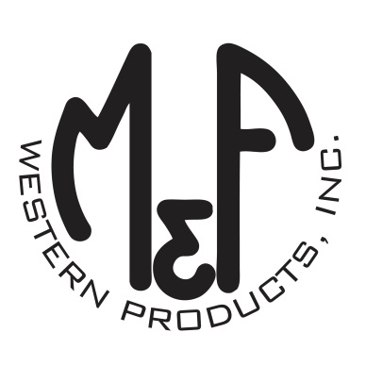

PRODUCT DESCRIPTION

**#A3000046156**

**Details**

* Ariat Mens Cap
* Multi
* One Size: Adjustable Snap Closure
* 6 Panels
* Embroidered Ariat Signature Logo
* Black Fabric Back
* Brown Digital Camo on Front and Bill
* Embroidered Eyelets
* Matching Fabric Button Sewn on Top
* Velcro Back
* 100% Cotton

**Description**  
  
*You will reach for this fashionable and comfortable Ariat cap by M&F Western Products each time you go out. There is a heavy stitched embroidered Ariat Signature Logo on the front of the digital camo print, and a black fabric back with velcro so you will get a perfect fit. You will love this great cap.*

