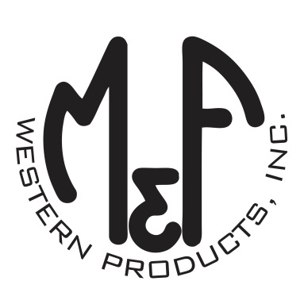

PRODUCT DESCRIPTION

**#A300004501**

**Details**

* Ariat Mens Cap
* Black
* One Size: Adjustable Snap Closure
* 6 Panels
* Ariat Signature Logo with Laser Flag Offset on Front
* Black Mesh Snap Back
* Black Digital Camo Under the Bill
* Embroidered Eyelets
* Matching Fabric Button Sewn on Top
* 7 Post Snap Closure
* 99% Polyester 1%Elastane

**Description**  
  
*You will reach for this fashionable and comfortable Ariat cap by M&F Western Products each time you go out. There is an offset Ariat Signature Logo with a laser cut flag on the front and a black mesh back with a snap closure so you will get a perfect fit. You will love this great cap.*

