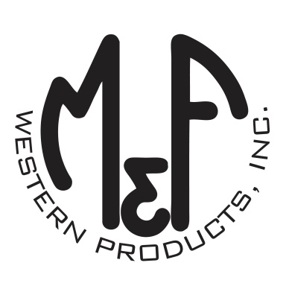
PRODUCT DESCRIPTION

#A300004030
Details
- Ariat Youth Cap
- Pink
- One Size: Adjustable Snap Closure
- 6 Panels
- Ariat Signature Logo on Front
- Multi Colored Fabric Back
- Embroidered Eyelets
- Matching Fabric Button Sewn on Top
- 7 Post Snap Closure
Description
Your little one will want to wear this comfortable and trendy Ariat cap by M&F Western Products every time she goes outside. There is multi colored Ariat Signature Logo patch on the front cap, and a multi colored fabric back with snap adjustments so she will get a perfect fit.

