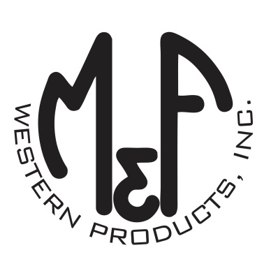

PRODUCT DESCRIPTION

**#A300003897**

**Details**

* Ariat Ladies Cap
* Multi Colored
* One Size: Adjustable Snap Closure
* 5 Panels
* Ariat Signature Logo on Front
* Stained Glass Design Print
* White Mesh Back
* Embroidered Eyelets
* Matching Fabric Button Sewn on Top
* 7 Post Snap Closure
* 100% Polyester Woven

**Description**  
  
*You will reach for this fashionable and comfortable Ariat cap by M&F Western Products each time you go out. There is an Ariat Signature Logo embroidered on the front of the stained glass design print cap, and a nylon mesh back with snap adjustments so you will get a perfect fit. You will love wearing this great cap.*

