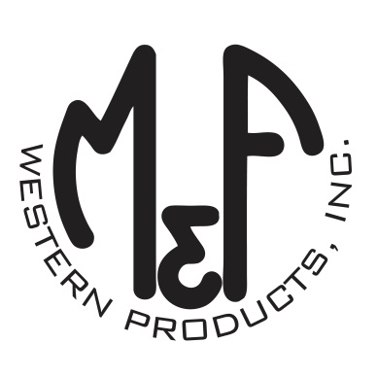

PRODUCT DESCRIPTION

**#A300003402**

**Details**

* Ariat Mens Cap
* Brown
* One Size: Adjustable Snap Closure
* 6 Panels
* Ariat Signature Logo Embroidered on Front
* Stone Tweed Crown
* Oilskin Bill
* Fabric Snap Back
* Embroidered Eyelets
* Matching Fabric Button Sewn on Top
* 7 Post Snap Closure

**Description**  
  
*You will reach for this fashionable and comfortable Ariat cap by M&F Western Products each time you go out. There is an Ariat Signature Logo embroidered on the front of the tan tweed crown, and a fabric back with snap adjustments so you will get a perfect fit. You will love to wear this great cap.*

