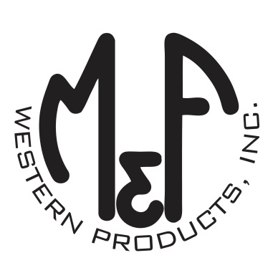

PRODUCT DESCRIPTION

**#A300003001**

**Details**

* Ariat Mens Cap
* Black
* One Size: Adjustable Snap Closure
* 6 Panels
* Fit: Richardson 112
* Ariat Signature Logo Patch on Front
* Black Mesh Back
* Embroidered Eyelets
* Matching Fabric Button Sewn on Top
* 7 Post Snap Closure
* Front Panels: 60% Cotton / 40% Polyester. Mesh: 100% Polyester

**Description**  
  
*You will reach for this fashionable and comfortable Ariat cap by M&F Western Products each time you go out. There is an Ariat Signature Logo embroidered on the front of the black crown, and a black mesh back with snap adjustments so you will get a perfect fit. You will love the all day comfort of this great cap.*

