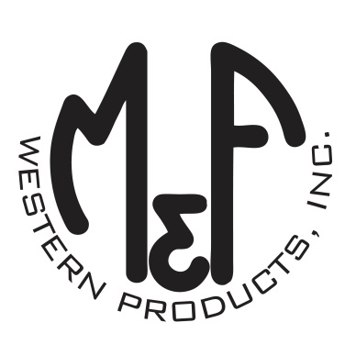

PRODUCT DESCRIPTION

**#A300002806**

**Details**

* Ariat Mens Cap
* Grey
* One Size: Adjustable Snap Closure
* 6 Panels
* Ariat Signature Logo Embroidered on Front
* Maroon Side Racing Stripes
* Fabric Snap Back
* Embroidered Eyelets
* Matching Fabric Button Sewn on Top
* 7 Post Snap Closure
* 100% Cotton Woven

**Description**  
  
*You will reach for this fashionable and comfortable Ariat cap by M&F Western Products each time you go out. There is an Ariat Signature Logo and maroon racing stripes embroidered on the front of the grey crown. A fabric back with snap adjustments will get you a perfect fit. You will love to wear this great cap.*

