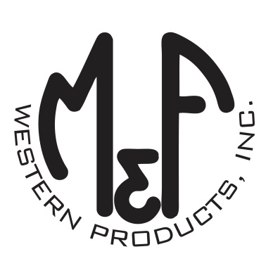

PRODUCT DESCRIPTION

**#A300001403**

**Details**

* Ariat Mens Cap
* Navy
* Sizes: S/M (6-3/4″ to 7-1/4″), L/XL (7-1/8″ to 7-5/8”)
* 6 Panels
* Medium High Profile, Structured
* Ariat Signature Logo Patch in Black and White
* All Over Navy Mesh
* Embroidered Eyelets for Ventilation
* Matching Fabric Button Sewn on Top
* 7 Post Snap Closure

**Description**  
  
*Keep the sun out of your eyes in style with this Ariat cap by M&F Western Products. This navy cap has a black and white embroidered Ariat Signature Logo patch on the front in black. The entire cap is mesh and comes in 2 sizes so you will get that perfect fit. You will reach for this good looking and functional cap every time you leave the house.*