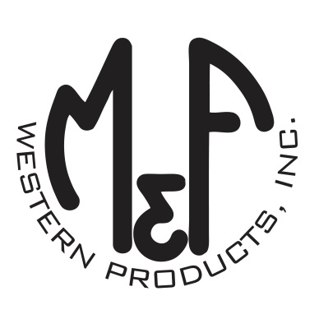

PRODUCT DESCRIPTION

**#A300001220**

**Details**

* Ariat Mens Cap
* Denim
* One Size: Adjustable Snap Closure
* 6 Panels
* Medium High Profile, Structured
* Ariat Signature Logo Suede Patch
* Tan Mesh Back
* Embroidered Eyelets for Ventilation
* Matching Fabric Button Sewn on Top
* 7 Post Snap Closure

**Description**  
  
*Keep the wind and sun at bay with this Ariat cap by M&F Western Products. This denim cap has a suede patch that features the Ariat Signature Logo on the front. The back is tan mesh and has a 7 post snap closure to get that perfect fit. You will reach for this good looking and functional cap every time you leave the house.*