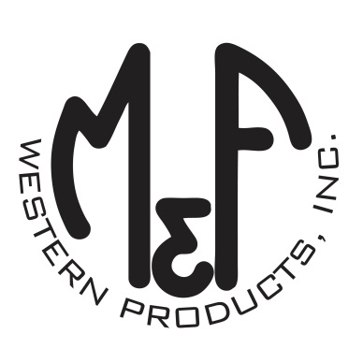

PRODUCT DESCRIPTION

**#A300001105**

**Details**

* Ariat Mens Cap
* White
* One Size: Adjustable Snap Closure
* 6 Panels
* Medium High Profile, Structured
* Ariat Signature Logo in Denim and Red
* All Over White Mesh
* Denim Bill
* Embroidered Eyelets for Ventilation
* Matching Fabric Button Sewn on Top
* 7 Post Snap Closure

**Description**  
  
*Hang out with your friends in style with this Ariat cap by M&F Western Products. This white cap has a denim and red Ariat Signature Logo on the front and side. The entire cap is mesh and has a 7 post snap closure to get that perfect fit. You will reach for this good looking and functional cap every time you leave the house.*