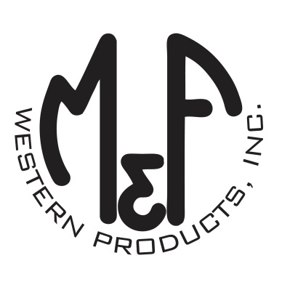

PRODUCT DESCRIPTION

**#A300001002**

**Details**

* Ariat Mens Cap
* Brown
* One Size: Adjustable Snap Closure
* 6 Panels
* Medium High Profile, Structured
* Ariat Signature Logo Patch
* All Over Brown Mesh
* Embroidered Eyelets for Ventilation
* Matching Fabric Button Sewn on Top
* 7 Post Snap Closure
* 60% Polyester 40% Cotton

**Description**  
  
*Hang out with your friends in style with this Ariat cap by M&F Western Products. This brown cap has an embroidered Ariat Signature Logo flag patch on the front in black. The entire cap is mesh and has a 7 post snap closure to get that perfect fit. You will reach for this good looking and functional cap every time you leave the house.*