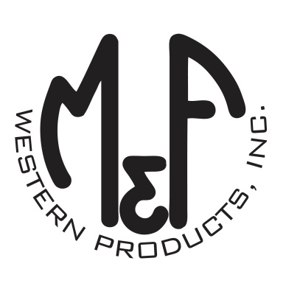

PRODUCT DESCRIPTION

**#A3000009156**

**Details**

* Ariat Mens Cap
* Multi Colored
* One Size: Adjustable Snap Closure
* 6 Panels
* Low Profile, Unstructured
* Camo Print
* Embroidered Ariat Signature Logo in Black
* Contrast Stitching
* Tan Mesh Back
* Embroidered Eyelets for Ventilation
* Matching Fabric Button Sewn on Top
* 7 Post Snap Closure

**Description**  
  
*Hang out with your friends in style with this Ariat cap by M&F Western Products. This camo print cap has a large embroidered Ariat Signature Logo on the front in black. The back is tan mesh and has a 7 post snap closure to get that perfect fit. You will reach for this good looking and functional cap every time you leave the house.*