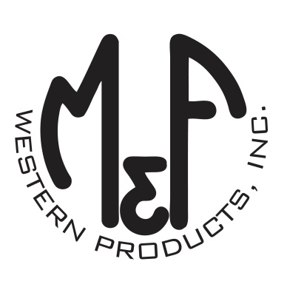

PRODUCT DESCRIPTION

**#A300000806**

**Details**

* Ariat Mens Cap
* Grey
* One Size: Adjustable Snap Closure
* 6 Panels
* Medium High Profile, Structured
* Embroidered Ariat Signature Logo in Red and White
* Contrast Stitching
* White Mesh Back
* Embroidered Eyelets for Ventilation
* Matching Fabric Button Sewn on Top
* 7 Post Snap Closure
* 50% Polyester 47% Rayon 3% PU

**Description**  
  
*Hang out with your friends in style with this Ariat cap by M&F Western Products. The grey cap has a large embroidered Ariat Signature Logo on the front in red and white. The back is white mesh and has a 7 post snap closure to get that perfect fit. You will reach for this good looking and functional cap every time you leave the house.*