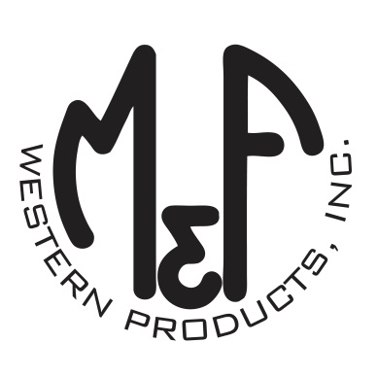

PRODUCT DESCRIPTION

**#A300000501**

**Details**

* Ariat Mens Cap
* Black
* One Size: Adjustable Snap Closure
* 6 Panels
* Fit: Richardson 112
* Ariat Signature Logo Patch on Front
* Grey Mesh Back
* Mesh Cotton Sweatband
* Contrast Stitching
* Embroidered Eyelets
* Matching Fabric Button Sewn on Top
* 7 Post Snap Closure
* Front Panels: 60% Cotton / 40% Polyester Mesh: 100% Polyester

**Description**  
  
*You will reach for this fashionable and comfortable Ariat cap by M&F Western Products each time you go out. There is an offset Ariat Signature Logo patch on the front of the black crown, and a grey mesh back with snap adjustments so you will get a perfect fit. A mesh cotton sweatband will give you all day comfort. You will love this great cap.*

