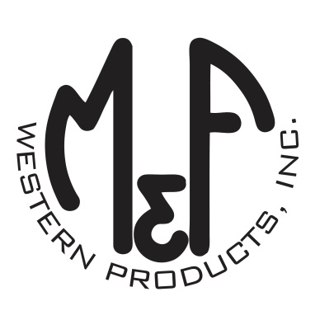

PRODUCT DESCRIPTION

**#A300000297**

**Details**

* Ariat Ladies Cap
* Multi Colored
* One Size: Adjustable Snap Closure
* 5 Panels
* Structured Crown
* Ariat Signature Logo Centered on Front
* Black Cotton Bill
* Serape Print Front Panel and Under Bill
* Embroidered Eyelets for Ventilation
* Matching Fabric Button Sewn on Top
* 7 Post Snap Closure

**Description**  
  
*Keep the wind and sun at bay with this ladies Ariat cap by M&F Western Products. The cap has a multi colored serape front with black mesh cover up, and a small Ariat Signature Logo centered on the front. The bill of the cap is black on the top, and the serape print under the bill for a nice contrasting look. The back 7 post snap closure to get that perfect fit. You will love the quality and comfort of this beautiful cap.*

