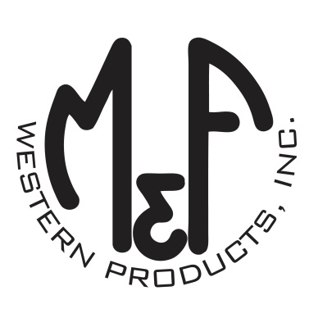

PRODUCT DESCRIPTION

**#A1800444**

**Details**

* Ariat Leather Knife Sheath Sleeve
* Medium Brown
* Exterior Measurements: 3-5/8” x 3”
* Opening: 1-1/2” x 1/4”
* Soft Leather Sheath
* Black Embossed Ariat Signature Logo
* Double Contrast Stitching
* 2 Slits to Slide Belt Through For Secure Fastening
* Fits Up to a 1-1/2” Belt

**Description**  
  
*Carry your favorite knife with you every day with this Ariat knife sheath sleeve by M&F Western Products. The sleeve is a quality medium brown leather with black embossed Ariat Signature Logo and double contrast stitching. Fits up to a 1-1/2” wide belt. Designed for pocket knives.*

