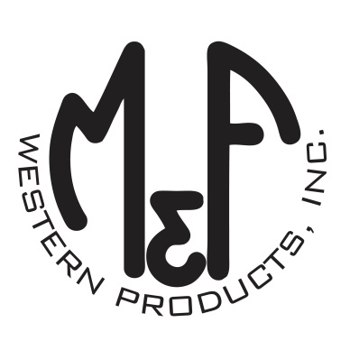

PRODUCT DESCRIPTION

**#9500008**

**Details**

* Western Moments Home Decor
* Metal Wall Hanging
* Silver
* Dimensions: 12” x 20”
* “Follow Your Dreams” Wording
* Multi Colored Arrow Motif
* 2 Metal Clips on Underside to Hang

**Description**  
  
*Add an authentic rustic feel to your home with this wall hanging by M&F Western Products. The metal sign has 4 arrows and the words “Follow Your Dreams” between the arrows. This inspirational wall hanging would make a great gift for that special person in your life, or buy for yourself.*

