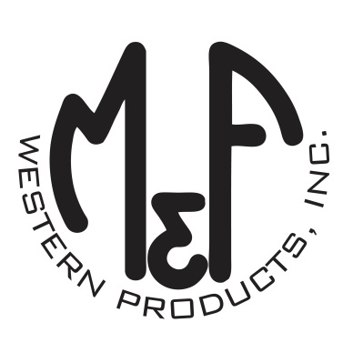

PRODUCT DESCRIPTION

**#9500007**

**Details**

* Western Moments Home Decor
* Metal Wall Hanging
* Silver
* Dimensions: 12” x 20”
* “With you I am Home” Wording
* Arrow Motif

**Description**  
  
*Add an authentic rustic feel to your home with this wall hanging by M&F Western Products. The metal sign has 2 arrows and the words “With You I am Home” between the arrows. This wall hanging would make a great gift for that special person in your life, or buy for yourself.*

