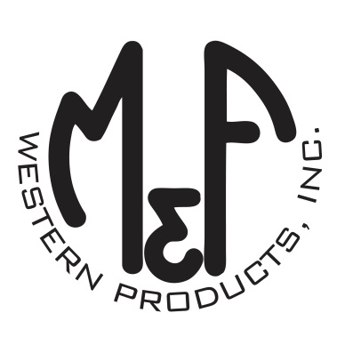

PRODUCT DESCRIPTION

**#9500006**

**Details**

* Western Moments Home Decor
* Metal Wall Hanging
* Silver
* Dimensions: 10” x 13”
* “Be Brave” Wording
* Arrow Motif

**Description**  
  
*Add an authentic rustic feel to your home with this wall hanging by M&F Western Products. The metal sign has 4 arrows and the words “Be Brave” on the bottom. This wall hanging would make a great gift for that special person in your life, or look great in your own home.*

