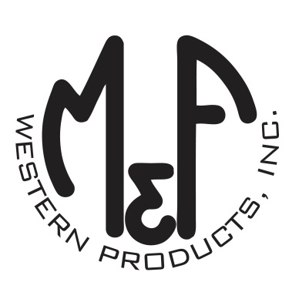

PRODUCT DESCRIPTION

**#9500004**

**Details**

* Western Moments Home Decor
* Cross Wall Hanging
* Silver/Ivory
* Dimensions: 15-3/4” x 11-1/2” (Including Rope)
* Dimensions: (Wall Hanging Only)
* Metal Sign with Ivory Cross on Top
* Hangs by Rope

**Description**  
  
*Add an authentic rustic feel to your home with this wall hanging by M&F Western Products. The metal sign has an ornate ivory cross on the top, and hangs on the wall with a rope. This wall hanging would make a great gift for that someone special, or buy for yourself.*

