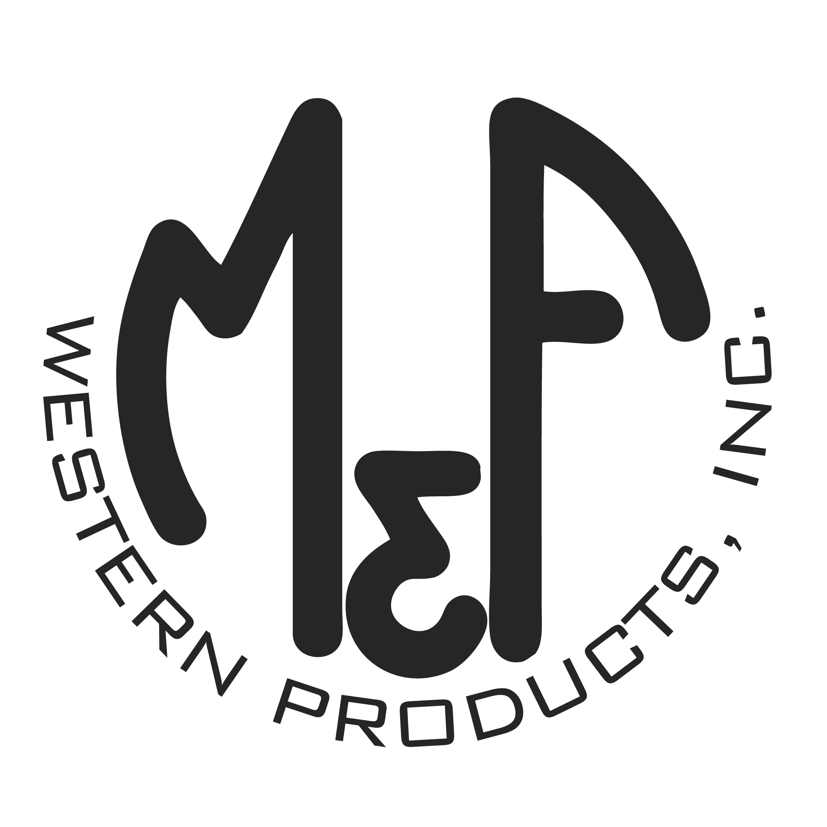

PRODUCT DESCRIPTION

# 2000601
Details

- Nocona Machine Woven Belt
- Brown
- 2000605 Adjustable up to Size: 46
- 2000605X Adjustable up to Size: 52
- 1-1/2" Wide Strap
- Nylon Braided Strap
- Brown and Tan Colored
- Removable D-Shaped Buckle
Description
Whether you are looking for a kids belt, or an adult belt, these are soft to wear and easily hold your favorite buckle. You will want several colors once you get the first one. Match your shirts or your favorite pair of boots, this is a perfect accessory for anything.

