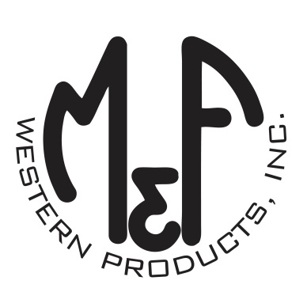
PRODUCT DESCRIPTION

#1801408
Details

- Nocona Belt Co
- Tan
- Size: Large
- Exterior: 4-1/4" x 2-1/4"
- For Pocket Knives: 3-1/2" x 1-1/2"
- Cross Draw Knife Sheath
- Top Grain Genuine Leather
- Basketweave Embossed Pattern
- Heavy Duty Contrast Stitched Edge
- Fixed Belt Loop for Secure Fastening
- Fits up to 2" Belt
Description
Carry your knife in style with this Nocona knife sheath by M&F Western Products. Top grain, genuine stained leather with basketweave embossing is designed to hold your favorite pocket knife securely in place without the use of a retaining strap. The horizontal positioning is designed for quick draw, as well as, a more comfortable wear when sitting.The fixed belt loop on the back fits up to a 2" wide belt.

