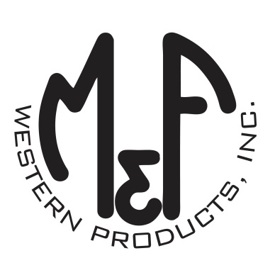
PRODUCT DESCRIPTION

#1519466
Details
- Ariat Youth Cap
- Black
- One Size: Adjustable Snap Closure
- 6 Panels
- Medium High Profile, Structured
- Red and Black Ariat Signature Logo
- Grey Mesh Back
- Contrast Stitching
- Embroidered Eyelets for Ventilation
- Matching Fabric Button Sewn on Top
- 7 Post Snap Closure
Description
Your little one will stand apart from the crowd in style in this Ariat cap by M&F Western Products. The cap has a black bill and brim with an Ariat signature logo on the front, as well as contrast stitching for a grown up look. The back is a grey mesh and is adjustable at 7 positions to get that perfect fit. Dress him up in style with this great cap.

