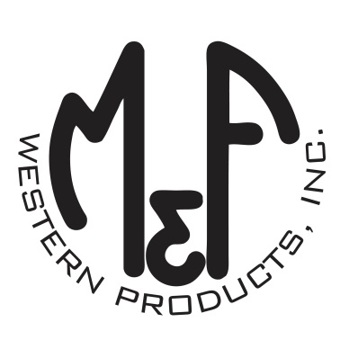
PRODUCT DESCRIPTION

#1513302
Details
- Ariat Youth Cap
- Multi Colored
- One Size: Adjustable Snap Closure
- 6 Panels
- Medium High Profile, Structured
- Aztec Print on Front
- Ariat Signature Logo on Front
- Brown Bill
- Tan Mesh Back
- Contrast Stitching
- Embroidered Eyelets for Ventilation
- Matching Fabric Button Sewn on Top
- 7 Post Snap Closure
Description
Your little one will stand apart from the crowd in style in this Ariat cap by M&F Western Products. The cap has a multi colored aztec print brim with a brown bill, and an Ariat signature logo on the front. There are embroidered eyelets and a fabric button on top, which gives this cap a classic look. The back is tan mesh and is adjustable at 7 positions to get that perfect fit.

