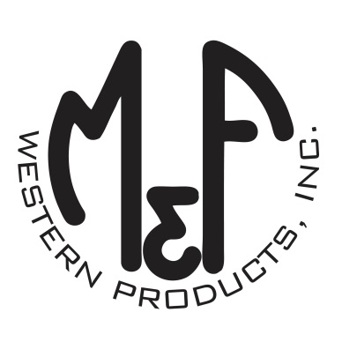
PRODUCT DESCRIPTION

#1518916
Details
- Ariat Youth Cap
- Purple
- One Size: Adjustable Snap Closure
- 6 Panels
- Medium High Profile, Structured
- Ariat Signature Logo on Front
- Pink Mesh Back
- Pink Contrast Stitching
- Embroidered Eyelets for Ventilation
- Matching Fabric Button Sewn on Top
- 7 Post Snap Closure
Description
Your little one will stand apart from the crowd in style in this Ariat cap by M&F Western Products. The cap is purple with an Ariat signature logo embroidered in pink on the front. There are embroidered eyelets and a fabric button on top, which gives this cap a classic look. The back is pink mesh and is adjustable at 7 positions to get that perfect fit.

