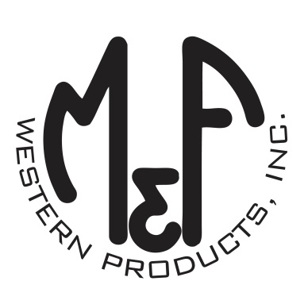
PRODUCT DESCRIPTION

#1518306
Details
- Ariat Mens Cap
- Grey
- One Size: Adjustable Snap Closure
- 6 Panels
- Medium High Profile, Structured
- Red, White and Black Ariat Signature Logo Patch
- White Mesh Back
- Embroidered Eyelets for Ventilation
- Matching Fabric Button Sewn on Top
- 7 Post Snap Closure
Description
Go out in style in this Ariat cap by M&F Western Products. The cap has a grey brim and bill with a red, white and black Ariat signature logo. The back is white mesh and has a 7 post snap closure to get that perfect fit. You will reach for this good looking and functional cap every time you leave the house.

