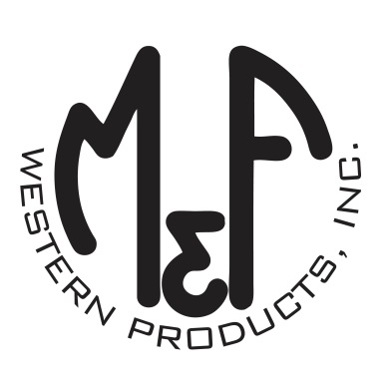
PRODUCT DESCRIPTION

#1518101
Details
- Ariat Youth Cap
- Black
- One Size: Adjustable Snap Closure
- 6 Panels
- Medium High Profile, Structured
- Grey Ariat Signature Logo on Front
- Black Mesh Back
- Embroidered Eyelets for Ventilation
- Matching Fabric Button Sewn on Top
- 7 Post Snap Closure
- 60% Polyester 40% Cotton
Description
Your little one will enjoy the cool style of this Ariat cap by M&F Western Products. The cap is black with an Ariat signature logo embroidered in grey on the front. There are embroidered eyelets and a fabric button on top, which gives this cap a classic look. The back is black mesh and is adjustable at 7 positions to get that perfect fit.

