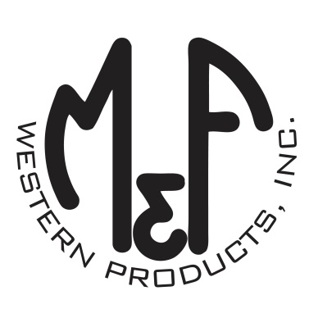
PRODUCT DESCRIPTION

#1517603
Details
- Ariat Mens Cap
- Navy
- One Size: Adjustable Snap Closure
- 6 Panels
- Medium High Profile, Structured
- USA Flag Accented with Ariat Signature Logo
- White Mesh Back
- Matching Fabric Button Sewn on Top
- 7 Post Snap Closure
- 60% Polyester 40% Cotton
Description
Show your patriotic side with this Ariat cap by M&F Western Products. The cap has a navy brim and bill with a USA flag accented with the Ariat signature logo. The back is white mesh and has a 7 post snap closure to get that perfect fit. You will reach for this good looking and functional cap every time you go out.

