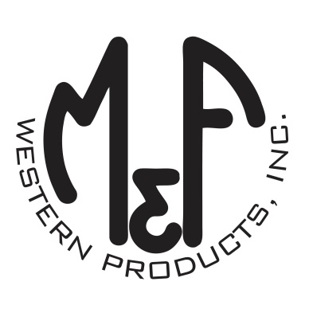
PRODUCT DESCRIPTION

#1517507
Details
- Ariat Mens Cap
- Charcoal Grey
- Sizes: S/M (6-3/4″ to 7-1/4″), L/XL (7-1/8″ to 7-5/8”)
- 6 Panel Flexfit Technology
- Medium High Profile, Structured
- Ariat Signature Logo in White Centered on Front
- Matching Fabric Button Sewn on Top
Description
Show your fashionable side with this Ariat Flexfit cap by M&F Western Products. The cap is a high quality of blend of materials designed to fit your head comfortably. The 6 panel charcoal grey cap has a small Ariat signature logo in white centered on the front. This popular cap looks good on any one and with 2 sizes available, you will get a great fit.

