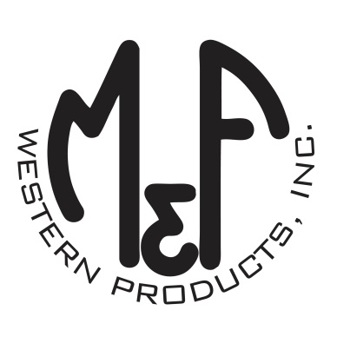
PRODUCT DESCRIPTION

#1517327
Details
- Ariat Mens Cap
- Blue
- One Size: Adjustable Snap Closure
- 6 Panels
- Medium High Profile, Structured
- Serape Bull on Front
- Ariat Signature Logo on Side
- Tan Mesh Back
- Embroidered Eyelets for Ventilation
- Matching Fabric Button Sewn on Top
- 7 Post Snap Closure
Description
Hang out at the barn in style with this Ariat cap by M&F Western Products. The cap has a blue brim and bill with a serape bull on the front and an Ariat signature logo on the side. The back is tan mesh and has a 7 post snap closure to get that perfect fit. You will reach for this good looking and functional cap every time you leave the house.

