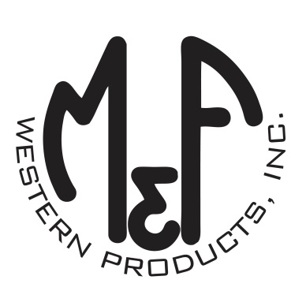
PRODUCT DESCRIPTION

#1516702
Details
- Ariat Mens Cap
- Brown
- One Size: Adjustable Snap Closure
- 6 Panels
- Medium High Profile, Structured
- Brown, Tan and Orange Ariat Signature Logo Patch
- Tan Mesh Back
- Embroidered Eyelets for Ventilation
- Matching Fabric Button Sewn on Top
- 7 Post Snap Closure
Description
Hang out with your friends in style with this Ariat cap by M&F Western Products. The cap has an oilskin brown brim and bill with a brown, tan and orange Ariat signature logo. The back is tan mesh and has a 7 post snap closure to get that perfect fit. You will reach for this good looking and functional cap every time you leave the house.

