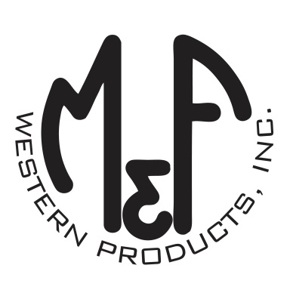
PRODUCT DESCRIPTION

#1516133
Details
- Ariat Ladies Cap
- Turquoise
- One Size: Adjustable Snap Closure
- 6 Panels
- Medium High Profile, Structured
- Ariat Signature Logo on the Front
- “#payyourdues” in Purple and Green
- White Mesh Back
- Embroidered Eyelets for Ventilation
- Matching Fabric Button Sewn on Top
- 7 Post Snap Closure
Description
Ride your horse in western fashion with this Ariat cap by M&F Western Products. The cap has a turquoise brim and bill, and a purple and green Ariat signature logo on the front. There is also “#payyourdues” on the front of the cap. The back is white mesh and has a 7 post snap closure to get that perfect fit. You will love the quality and comfort of this beautiful cap.

