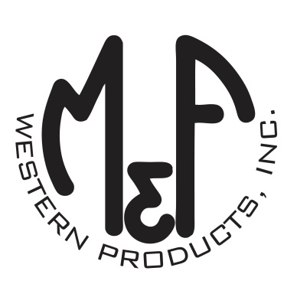

PRODUCT DESCRIPTION

**#1515997**

**Details**

* Ariat Ladies Cap
* Multi Colored
* One Size: Adjustable Snap Closure
* 6 Panels
* Medium High Profile, Structured
* Bright Color Serape Brim and Bill
* Ariat Signature Logo on the Front in Black
* White Mesh Back
* White Contrast Stitching
* Embroidered Eyelets for Ventilation
* Matching Fabric Button Sewn on Top
* 7 Post Snap Closure
* 100% Polyester Woven

**Description**  
  
*Ride your horse in western fashion with this Ariat cap by M&F Western Products. The cap has a multi colored serape brim and bill, and a black Ariat signature logo on the front. The back is white mesh and has a 7 post snap closure to get that perfect fit. You will love the quality and comfort of this beautiful cap.*

