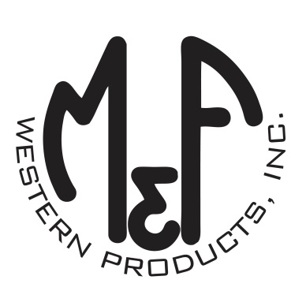
PRODUCT DESCRIPTION

#1514913
Details
- Ariat Mens Cap
- Light Blue
- One Size: Adjustable Snap Closure
- 6 Panels
- Medium High Profile, Structured
- Red, White and Blue Ariat Signature Logo Patch
- White Mesh Back
- Embroidered Eyelets for Ventilation
- Matching Fabric Button Sewn on Top
- 7 Post Snap Closure
Description
Go out in style in this Ariat cap by M&F Western Products. The cap has a light blue brim and bill with a red, white and blue Ariat signature logo. The back is white mesh and has a 7 post snap closure to get that perfect fit. You will reach for this good looking and functional cap every time you leave the house.

