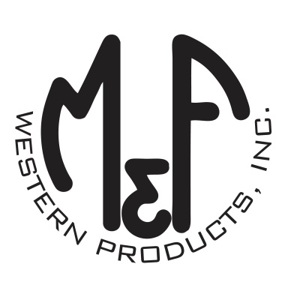
PRODUCT DESCRIPTION

#1504933
Details
- Ariat Mens Cap
- Black Heather
- One Size: Flexfit 110 Comfort Fit Technology
- 6 Panel Flexfit Technology
- Medium High Profile, Structured
- Ariat Signature Logo in Black
- White Mesh Back
- Holographic Flexfit 110 Brim Sticker
- Embroidered Eyelets
- Matching Fabric Button Sewn on Top
- 7 Post Snap Closure
Description
Step out with your friends in this fashionable Ariat Flexfit cap by M&F Western Products. The unique Flexfit 110 technology keeps a snug, comfortable fit while allowing the flexibility of adjustment with a snap back. You will reach for this great cap every time you go out.

