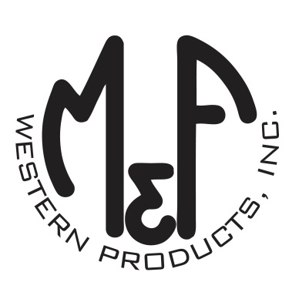

PRODUCT DESCRIPTION

**#0905804**

**Details**

* Wild Rag
* Red and Black
* 33” x 33”
* 13.5mm Weight
* Bronc Rider Design
* 100% Silk

**Description**  
  
*This wild rag by M&F Western Products is a classic western accessory that every cowboy and cowgirl needs. They are great for adding some color to your outfit or keeping the dust off of your face. 100% silk for ultimate luxury. The silk will help you feel cooler in the summer and warmer in the winter.*

